Killermont EYC
Our Vision
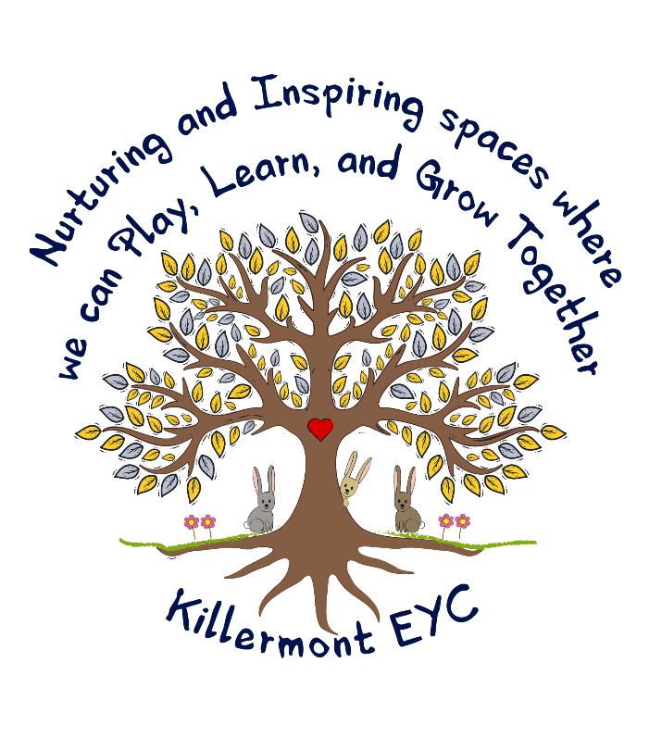

Our Values



Our Aims

At Killermont EYC we aim to:

- Actively give children time to talk about their emotions, ensuring their physical and mental health is at the heart of everything we do.

- Provide a safe, fun and nurturing environment indoors and out, where children are encouraged to reach their full potential.

- Create an inclusive ethos where our children are celebrated as individuals and their needs and beliefs are respected.

- Have a skilled and motivated staff team that takes an active role in their professional development journey to ensure high quality interactions and experiences for children.

- Provide a curriculum indoors and out that will facilitate fun, play based experiences that promote independence and foster positive attitudes to learning.

